Title of proposed monument:

Proposed location (be very specific: which street corner and park?):

Directly in front of the Kadıköy Ferry Terminal, on the waterfront plaza facing the main entrance, where ferry commuters, shoppers, and visitors cross the open pedestrian square.

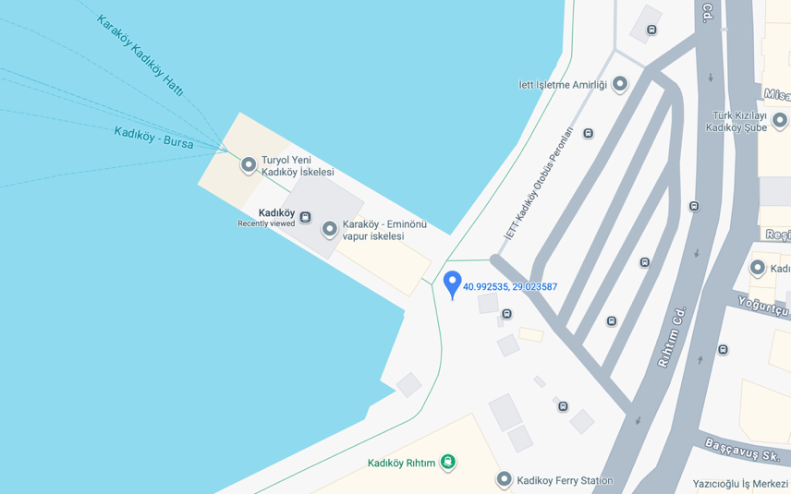
Figure 1, Location
- Describe the design and materials of the proposed sculpture in 5–6 sentences. (Insert a drawing, collage, or computer-generated image into your presentation PowerPoint.)

The proposed 3.8-meter-tall sculpture depicts Mustafa Kemal Atatürk kneeling on one knee, his torso slightly hunched forward in a posture of solemn reflection. One hand supports his weight while the other hand lifts his iconic fedora to cover his face. This gesture symbolizes both a refusal to witness the country’s current state and a desire to shield citizens from his sorrow. The figure will be cast in galvanized steel, chosen for its durability, resilience to weather, and industrial aesthetic that reinforces themes of strength and endurance. The sculpture’s surface will be left slightly textured to evoke age, struggle, and the passage of time. Its scale, materiality, and expressive pose are designed to confront viewers with both emotional power and national self-reflection.

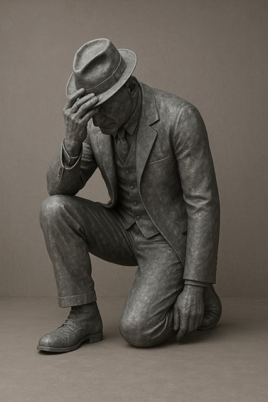
Figure 2, DISAPPOINTMENT

- What is the monument celebrating? How does the monument recognize and celebrate cultural diversity, innovation, or heroism? (4–5 sentences)
Rather than celebrating a singular victory, the monument honors Atatürk’s enduring legacy of modernism, reform, and democratic aspiration. It emphasizes the emotional weight carried by the founder of the Republic, representing the heroism not only of Atatürk but of the generations who inherited his vision. By portraying him in an untraditional, vulnerable pose, the monument acknowledges the diversity of experiences—joy, pain, hope, and disappointment—that shape a nation’s story. It challenges conventional heroic iconography and instead celebrates the innovation of emotional honesty in public monuments. This reflective approach invites citizens from all cultural and political backgrounds to engage in a shared moment of national introspection.

- Who are the viewers or community members of the monument? How does the monument connect to this local community? (3–4 sentences)

The primary viewers are the thousands of daily commuters, residents, vendors, and visitors who pass through the Kadıköy Ferry Terminal. This area is one of Istanbul’s most culturally diverse and politically expressive public spaces, making it a natural site for civic dialogue. The monument connects to this community by transforming a familiar transit hub into a site of emotional and historical reflection. It speaks directly to citizens who feel intertwined with the country’s past, present, and uncertain future.

- What will the monument’s plaque say? (3–4 short lines, organized how it will appear on the plaque).

HAYAL KIRIKLIĞI
Mirasın ağırlığına ve hayal kırıklığının sessizliğine bir övgü.
Anonim olarak yaratıldı — güvenlik ve ifade özgürlüğü uğruna bir fedakarlık.
Türkiye vatandaşları uğuruna.

DISAPPOINTMENT
A tribute to the weight of legacy and the silence of disappointment.
Created anonymously — a sacrifice for safety and expression.
For the citizens of Türkiye.

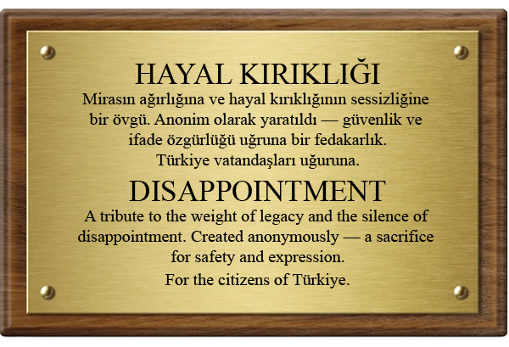
Figure 3, Plaque
- How is the proposed location of the monument appropriate for it? How will the proposed location be affected by the presence of the monument? (4–5 sentences)

Kadıköy’s ferry terminal is one of Istanbul’s busiest and most symbolically charged crossroads, serving as a bridge between continents, ideologies, and generations. Placing the monument here positions it at the heart of public dialogue, where its emotional message cannot be ignored. The sculpture will transform the area from a purely functional transit space into a site of reflection and civic engagement. The presence of the kneeling figure will challenge passersby to confront themes of responsibility, national direction, and collective memory. Over time, the location will likely become a gathering point for conversation, remembrance, and public expression.

- What is the monument’s potential for long-term impact within its community? How will the monument age and withstand its natural environment? What long-term care plans will the monument need? (4–5 sentences)

The monument’s long-term impact comes from how its material condition becomes part of its message. Because it uses galvanized steel—durable, industrial, and difficult to break—it can withstand Istanbul’s coastal environment while slowly weathering and darkening, much like the history it represents. Its raw, textured surface will continue to symbolize struggle and age as the years pass. The community’s care for the sculpture will shape its meaning: regular maintenance will signal a nation that protects its values, while neglect or rust will reflect a country drifting away from them. To preserve its integrity, the monument will need periodic inspections, renewed protective coatings, and routine cleaning to keep its form and plaque legible.

